SPEN method on Bruker Paravision 6.0x - User instructions
Maxime Yon – maxime.yon@weizmann.ac.il

Ultrafast MRI remain a key component in a wide range of imaging applications including functional imaging or Diffusion Weighted and Diffusion Tensor Imaging (DWI & DTI). Most of these application are based on Echo Planar Imaging (EPI) detection scheme. However, EPI faces known challenges when targeting heterogenous tissues, when operating at high magnetic fields, or in other instances where field inhomogeneities become important. Recently, another ultrafast acquisition schemes based on Spatiotemporal Encoding (SPEN) have been proposed to collect the 2D NMR and MRI data within a single scan. A number of features make SPEN a robust alternative to EPI^{1–3}: SPEN can be implemented in a fully T₂*-refocused manner where inhomogeneities are compensated throughout the acquisition, and its bandwidth along the blipped dimension –the more artifact prone in EPI– is defined at the excitation stage by a chirp pulse that can be set at arbitrary values. Another characteristic of SPEN acquisitions is the direct recording of the image in spatial space along the low-bandwidth dimension: as each signal gives a low-resolution image, it is then easier to apply a referenceless motion correction between shots and obtain data free from motional artifacts in multishot and/or interleaved acquisitions^{4–6}. Last but not least, SPEN’s use of a chirp pulse applied in conjunction with an encoding gradient induces a spatial selectivity, which permits zooming without folding along the low-bandwidth SPEN dimension.

This package contains a fully T₂* refocused version of the SPEN method based on a 180° chirp pulse developed for Bruker MRI systems running Paravision 6.0 on Avance III/IIIHD systems (see pulse programs in figure 1). The method allows single-shot or interleaved/segmented acquisition with single-slice, multi-slice 2D or 3D phase encoded acquisitions, diffusion encoding, CEST weighting, and multi echo acquisitions. The sequences work – but of course use is the operator’s responsibility

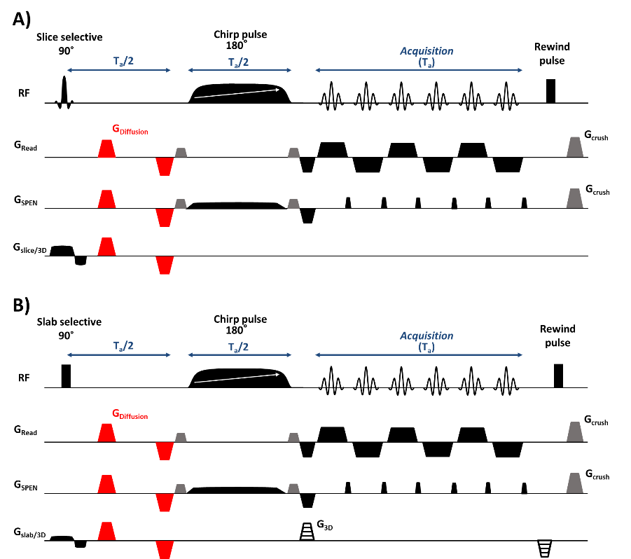
Figure 1: Sequence design for: A) 2D multislices SPEN DTI and B) 3D Phase encoded SPEN DTI. The SPatiotemporal ENcoding (SPEN) replaces the more artifact-prone, low bandwidth EPI dimension.

- Installation
I.1 Requirements
The SPEN method runs on Bruker Paravision 6.0x installed on Linux CentOS 5 or 7.

I.2 Installation
1) Unzip the SPEN package corresponding to your version of Centos.

2) Import and install the Paravision 6 source method: mySPEN180 _6.0.1.PvUserSrcMethod with: Files/Import/Source method

3) Copy the macro file: launchSPENprocess in: /opt/PV6.0.1/prog/curdir/USER/ParaVision/macros/launchSPENprocess
USER should be you user name.

For Centos 7
4) Log as Super User and execute the file: ./MyAppInstaller_web.install
This will download and install the Matlab Runtime environment which is used to perform the reconstruction of the SPEN data. You need an internet connection at this stage.

5) Copy somewhere the location of the installed files: the processing program and the runtime.
It should be something like:
/usr/Weizmann_Institute_of_Science/SpenProcess
and: /usr/local/MATLAB/MATLAB_Runtime

You will have to past these locations in the line 26 of the macro launchSPENprocess.

For Centos 5
4.a) Go to : http://www.mathworks.com/products/compiler/mcr/index.html
And download the Matlab Runtime 8.1 corresponding to R2013a for Linux 64 bits.

4.b) Log as Super User and unzip the download file : unzip ../download/ MCR_R2013a_glnxa64_installer.zip
And install it with the command: ./install

4.c) Edit the macro launchSPENprocess with a text editor and copy the location of the Runtime in the line 26. It should be something like: /usr/local/MATLAB/MATLAB_Compiler_Runtime/v81

5.a) Copy the folder SpenProcess in the user document.

5.b) In the line 26 of the macro launchSPENprocess, copy also the location of the run_SpenProcess.sh located in SpenProcess/src.

6) Make sure that both the processing program: SpenProcess and run_SpenProcess.sh script are allowed to be executed by looking at the permission and enabling "allows to be executed"
They should be located in: /usr/Weizmann_Institute_of_Science/SpenProcess

7) If you use the CEST option and the Image display and ISA utility you can copy the Zspectrum_SPEN in /opt/PV6.0.1/prog/curdir/USERNAME/ParaVision/isa/src, you can then use this function.

The SPEN sequence and reconstruction is now fully operational on your scanner!

I.3 First use
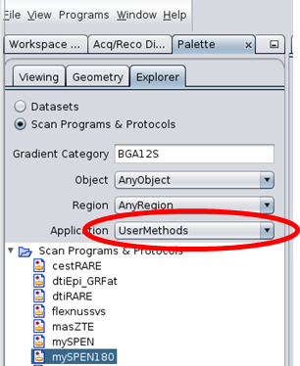
- The sequence mySPEN180 is accessible under “UserMethods”
in the palette after been installed in the Workspace Explorer

- The sequence mySPEN180 exhibit the same classical parameters (echo time, repetition time, 3D…) as any other Bruker pulse sequence. The only specific parameter is the “Targeted Time BW prod” which allow the user to control the Chirp gradient strength. The chirp gradient duration (controlling the chirp bandwidth) is automatically set to half of the acquisition duration to be in the fully T₂* refocused condition.

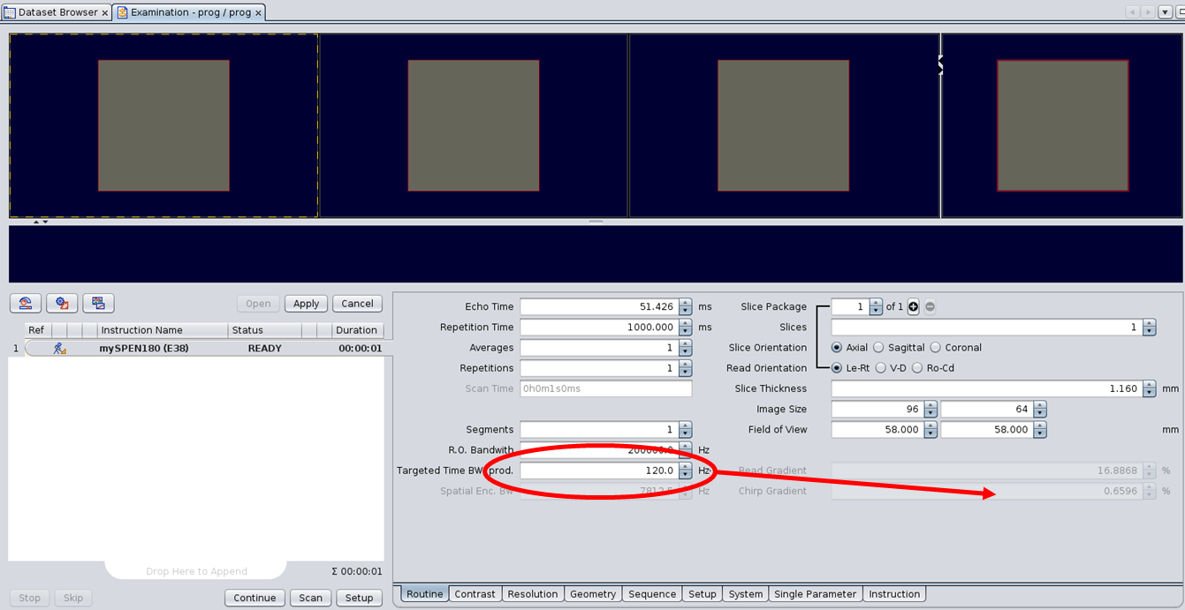

- The diverse contrast possibilities: Diffusion, CEST, multi-echo acquisition are available through the windows “Constrast”. These options can be used simultaneously. The Diffusion B-value calculated by Paravision are only approximate. A Matlab additional code is necessary to compute the exact ones.
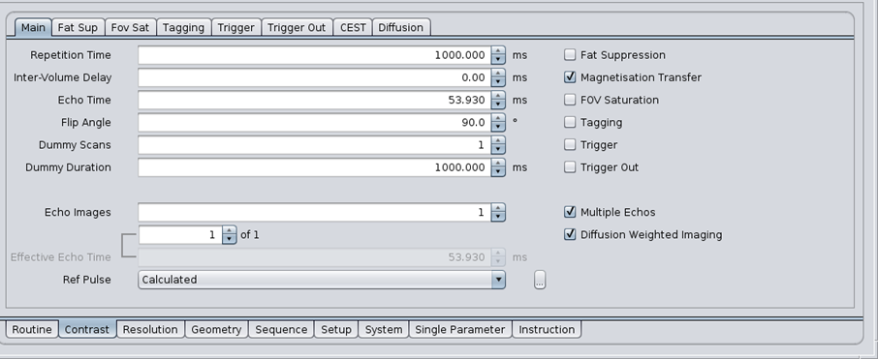

- To perform the reconstruction, you must call the macro “LaunchSPENprocess”
This call can be done automatically after the acquisition by adding a macro instruction in the "instruction/Execute Macro/USER/launchSPENprocess". The macro “LaunchSPENprocess” will be available under your user name. At the end of the acquisition, you should see the message "Executing post acquisition process".
Wait for the message to disappear and look at your first SPEN image!!!!

If you prefer to perform the reconstruction later, you can always call the macro from the EXPNO folder of the SPEN acquisition.




