How to share a Zoom recording (with downloading capabilities)
Stage 1:
Enter “Recordings” than at the requested recording press “Share”-
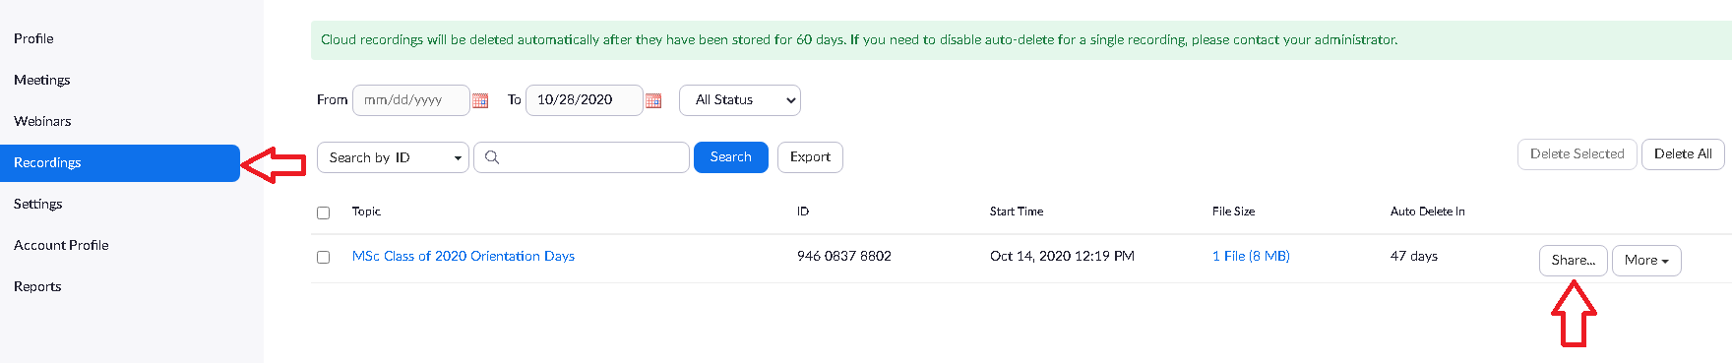
Stage 2:
Make sure that “Share this recording” is “On” and you chose “Publicly”. Also, make sure that “Viewers can download” is “On”-
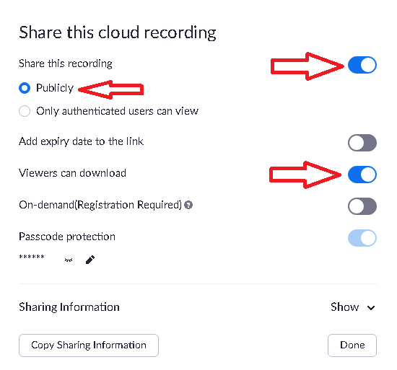
Stage 3:
Share the recording link with the requested person.

